**Inatech - .Net Training – Day 3 Taks**

1. **Write a program to implement the membership package for different types of Membership.**

**Each membership has different benefits in terms of accommodation and Food.**

**You may choose to implement the abstract class or interface to achieve the same**

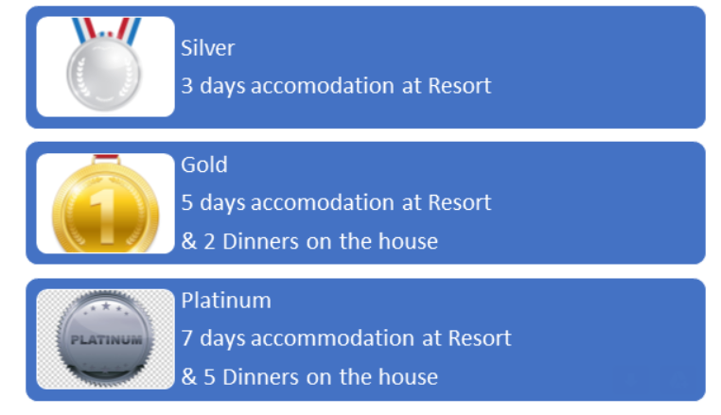

1. **Write a program to get the employee details.**

**Employee has the EmployeeID, Name, Gender, YearsOf Experience, Salary .**

**Employees belong to Sales & Marketing and Production Departments.**

**Sales & Marketing gets 20% bonus of their salary. Write a method to calculate the total salary.**

**Production gets 10% bonus of their salary. Write a method to calculate the total salary.**

**Implement Inheritance and achieve the task.**

**Should print the employee details with salary and bonus.**